
SHIRE HIGHLANDS EDUCATION DIVISION
2026 MALAWI SCHOOL CERTIFICATE OF EDUCATION MOCK
EXAMINATION

TECHICAL DRAWING

PAPER I
(100 marks) Subject Number: M201/I
PROVISIONAL MARKING KEY

SECTION A- PLANE GEOMETRY
- A point moves in a plane in such a way that its eccentricity is 3:4. Given that the distance between a fixed point and a fixed line is 35 mm:
- Plot the curve (12 marks)
- Name the curve (1 mark)
- Construct a tangent to the curve at any point ‘P’. (7 marks)

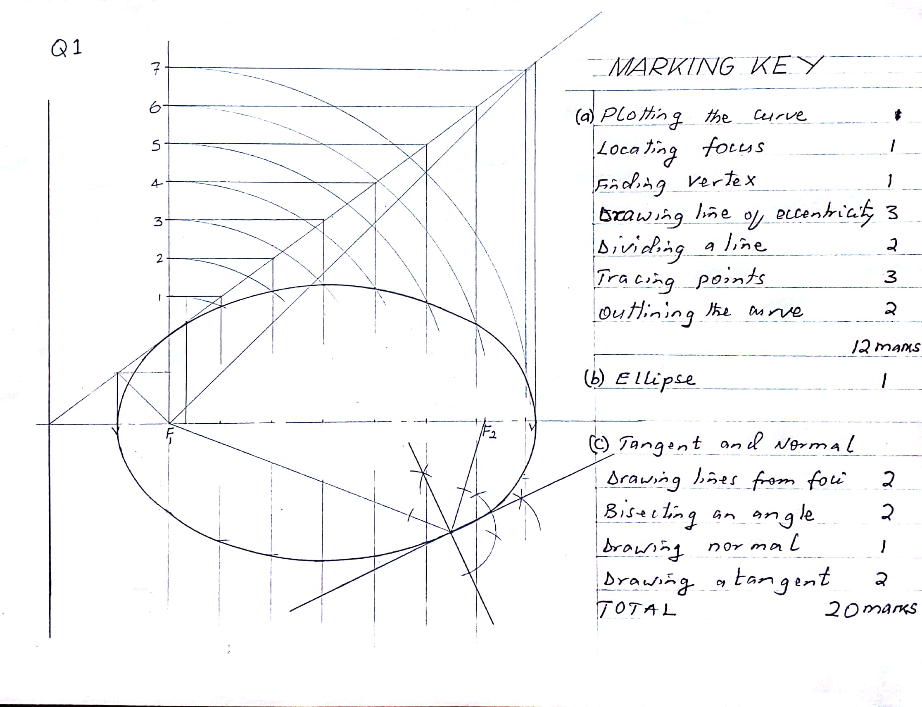

- Figure 1 shows the view of a CAM.
Construct, full size, the given view. Clearly show the methods of construction for all the centres of radii, and the points of tangency. (20 marks)
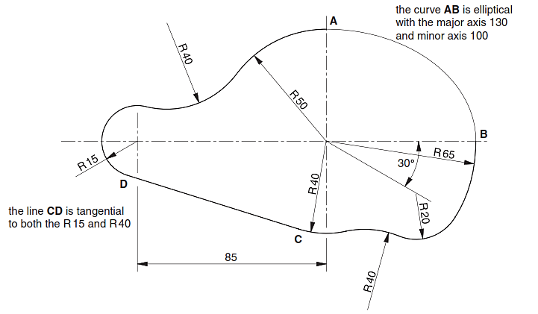 Figure 1

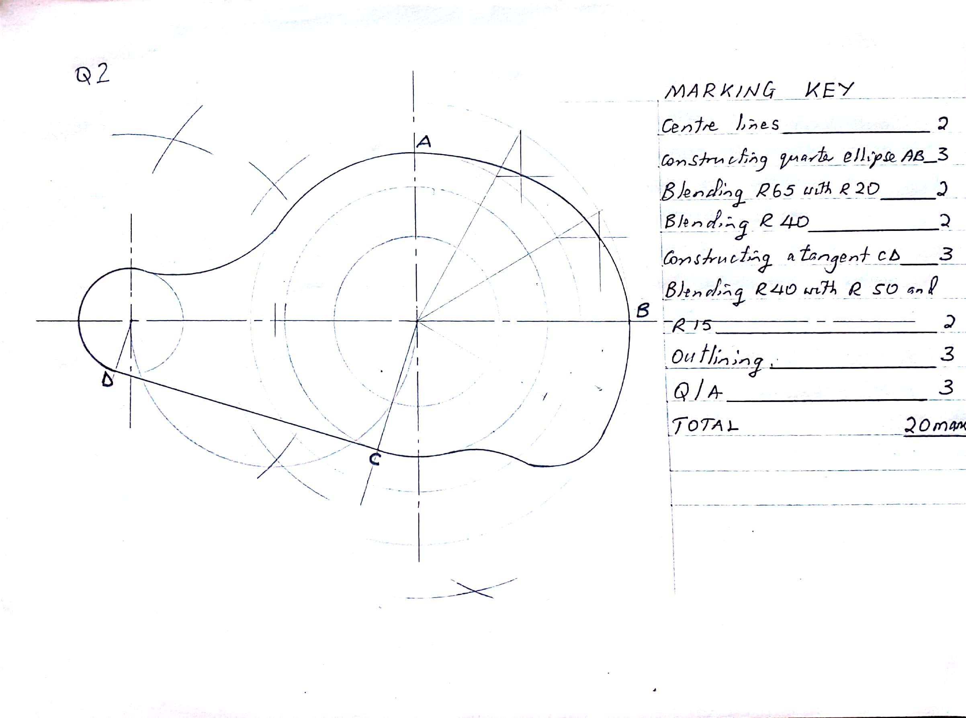

- Figure 2 shows one position of a simple mechanism. Link OB rotates about O. link ABC moves so that A can only travel along the axis XX. Link CP always remains vertical.
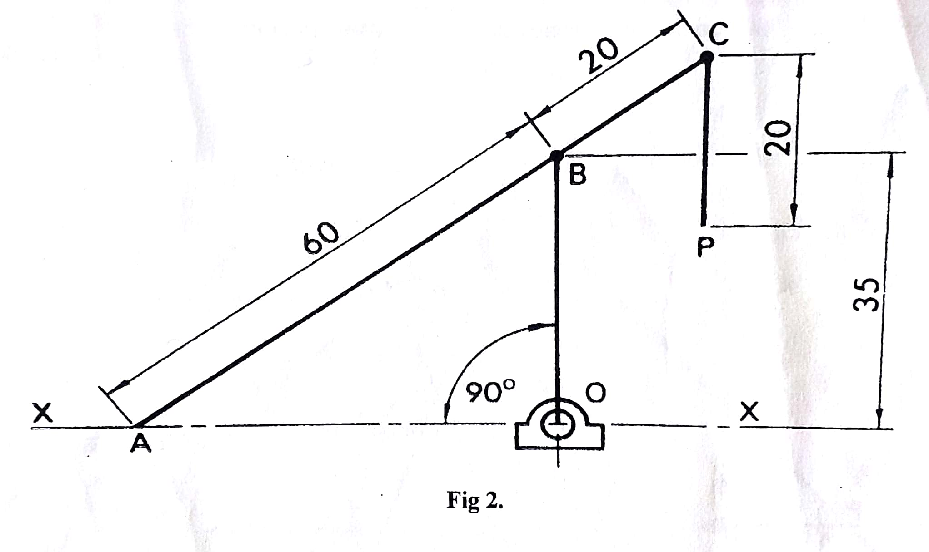 Plot full size, the path of P as B makes one revolution (20 marks)

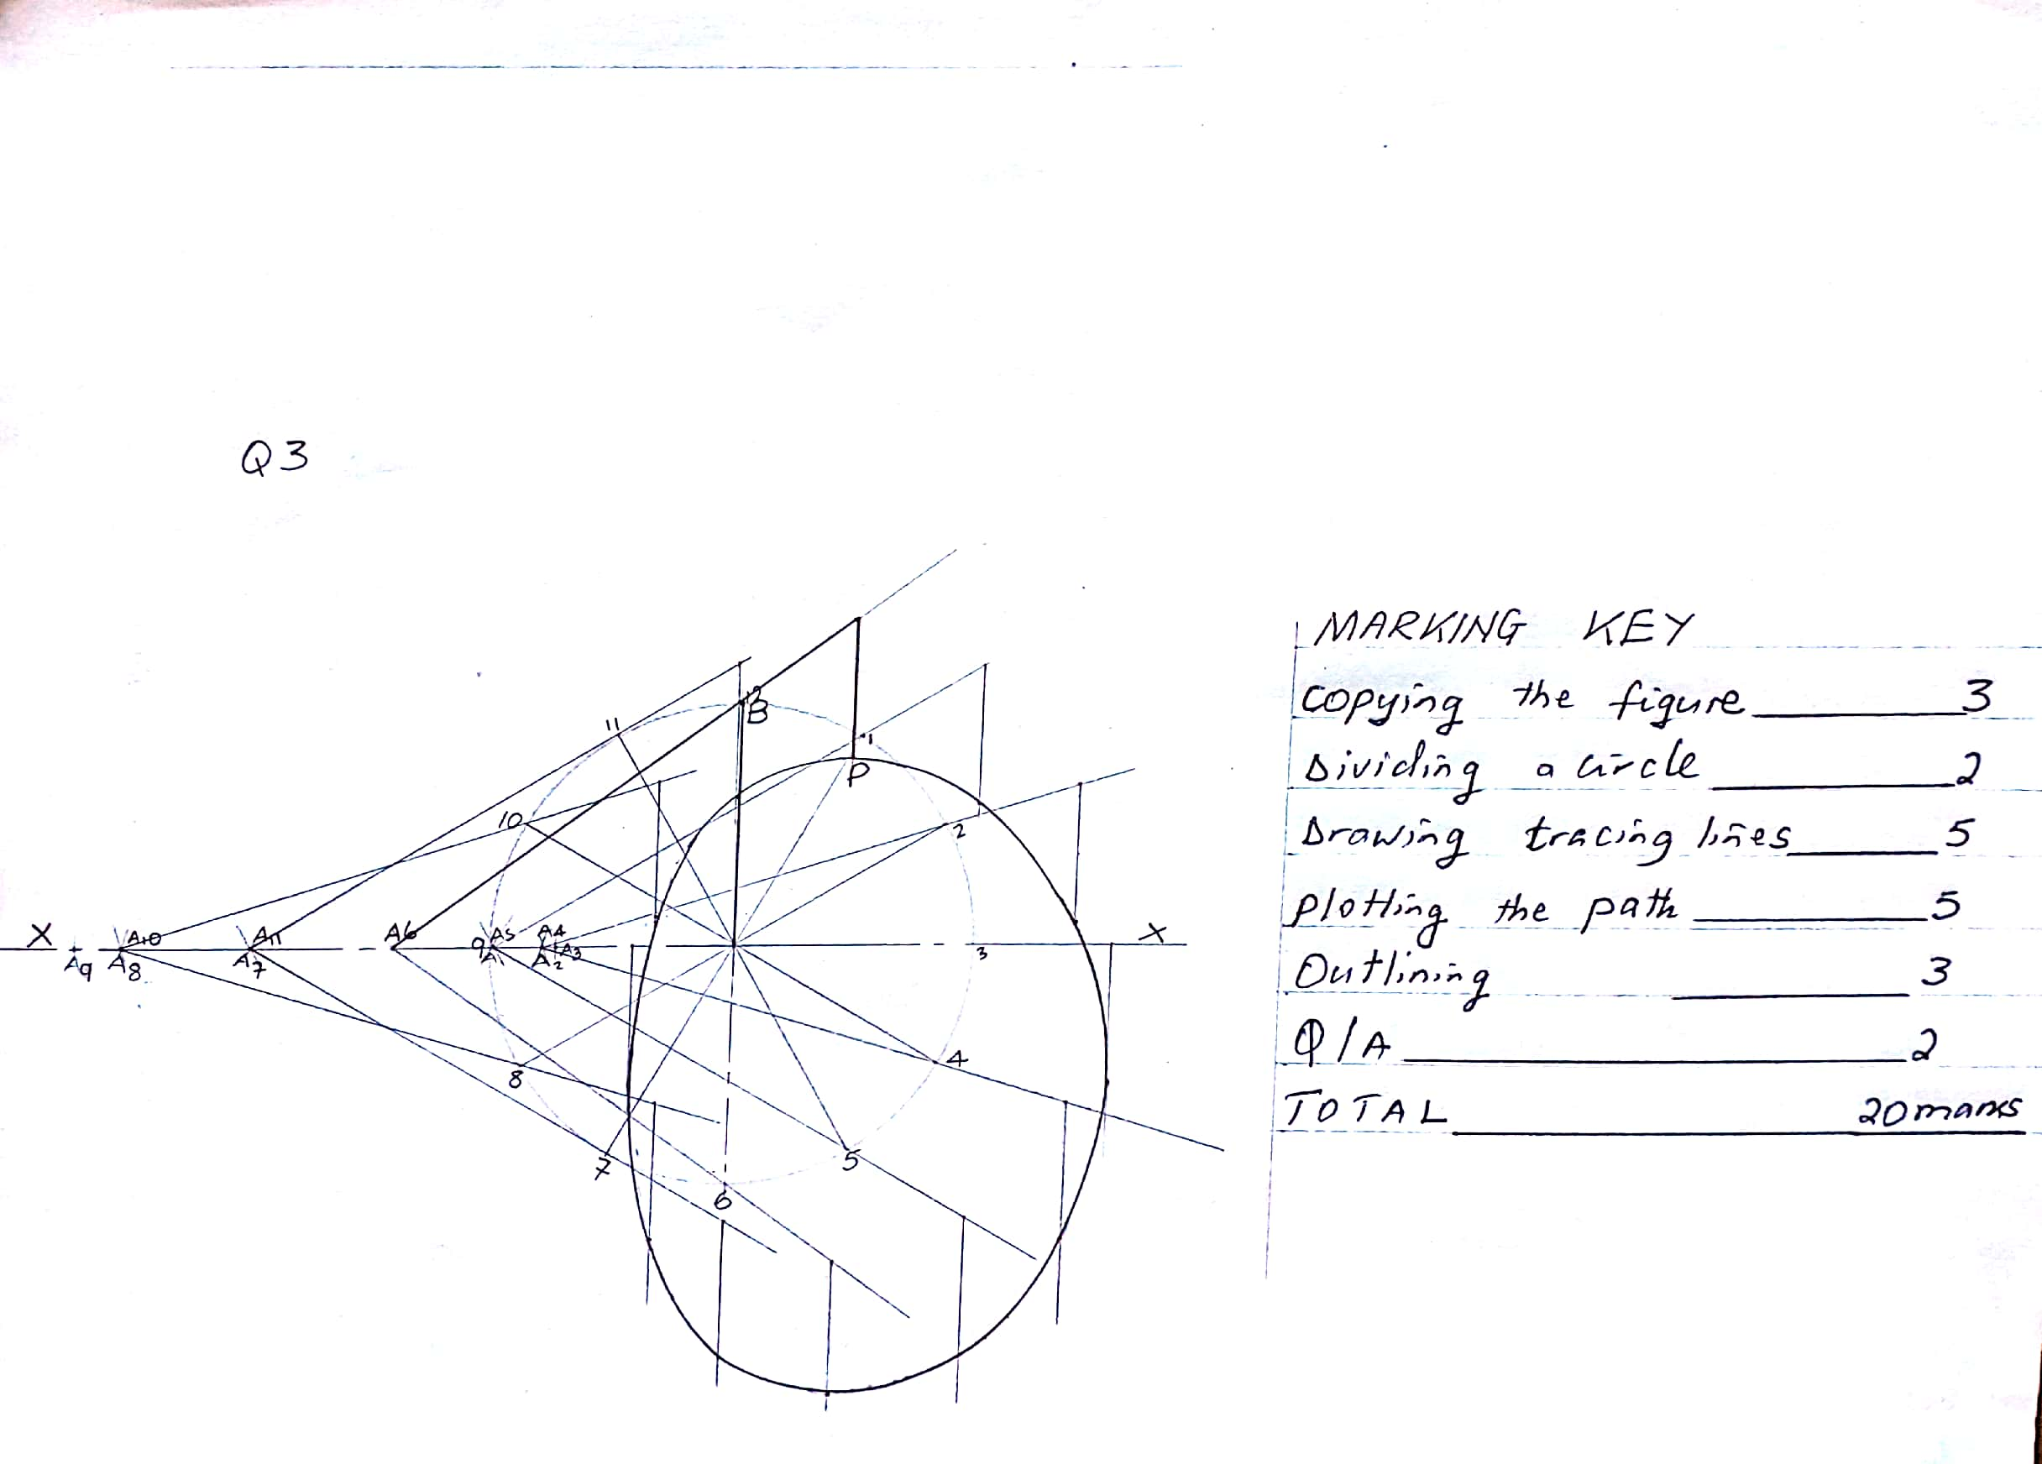

- Construct a diagonal scale of 25 mm to tepresent 1 m to read in metres and centimetres up to 5 metres (12 marks)
- Use the scale constructed in (a) to construct a quadrilateral PQRS with PQ = 3.72 m, QR = 2.53 m, PS = 3.17 m, angle PQR = 120⁰ and angle SPQ = 90⁰ (8 marks)

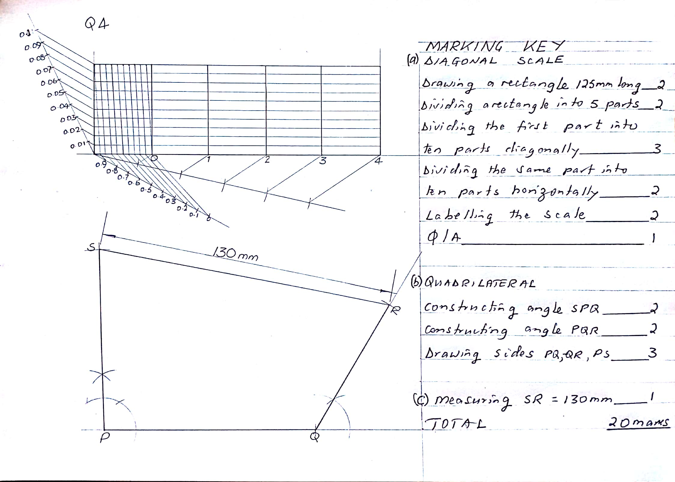

SECTION B- SOLID GEOMETRY
- Figure 3 shows two views of a block drawn in first angle orthographic projection. Draw the block in Isometric projection with corner X as the lowest point. (20 marks)

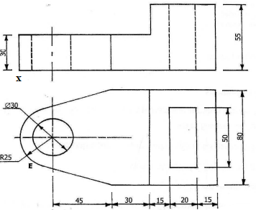

Figure 3
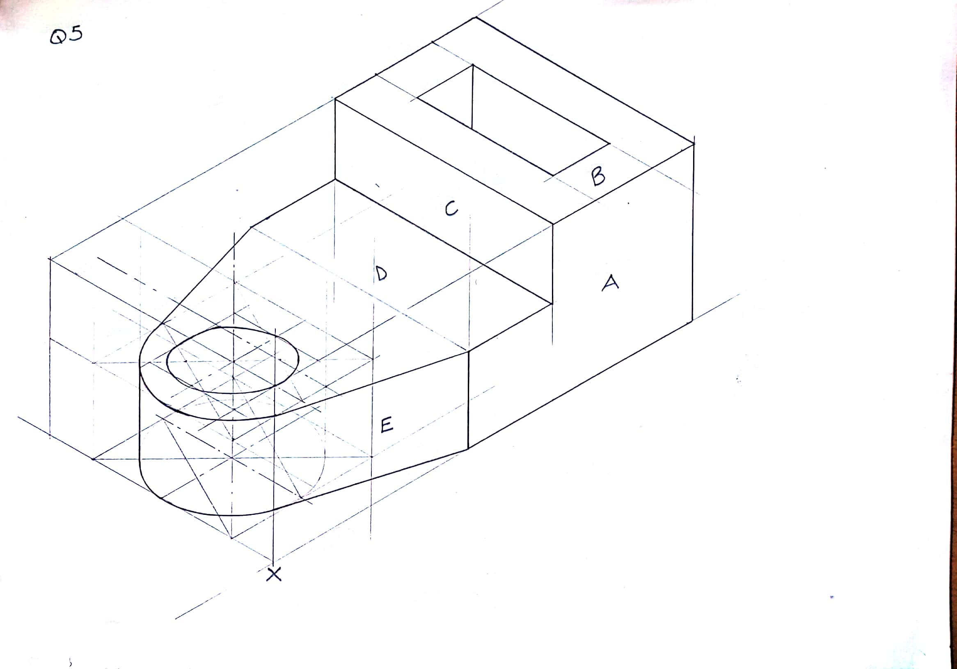

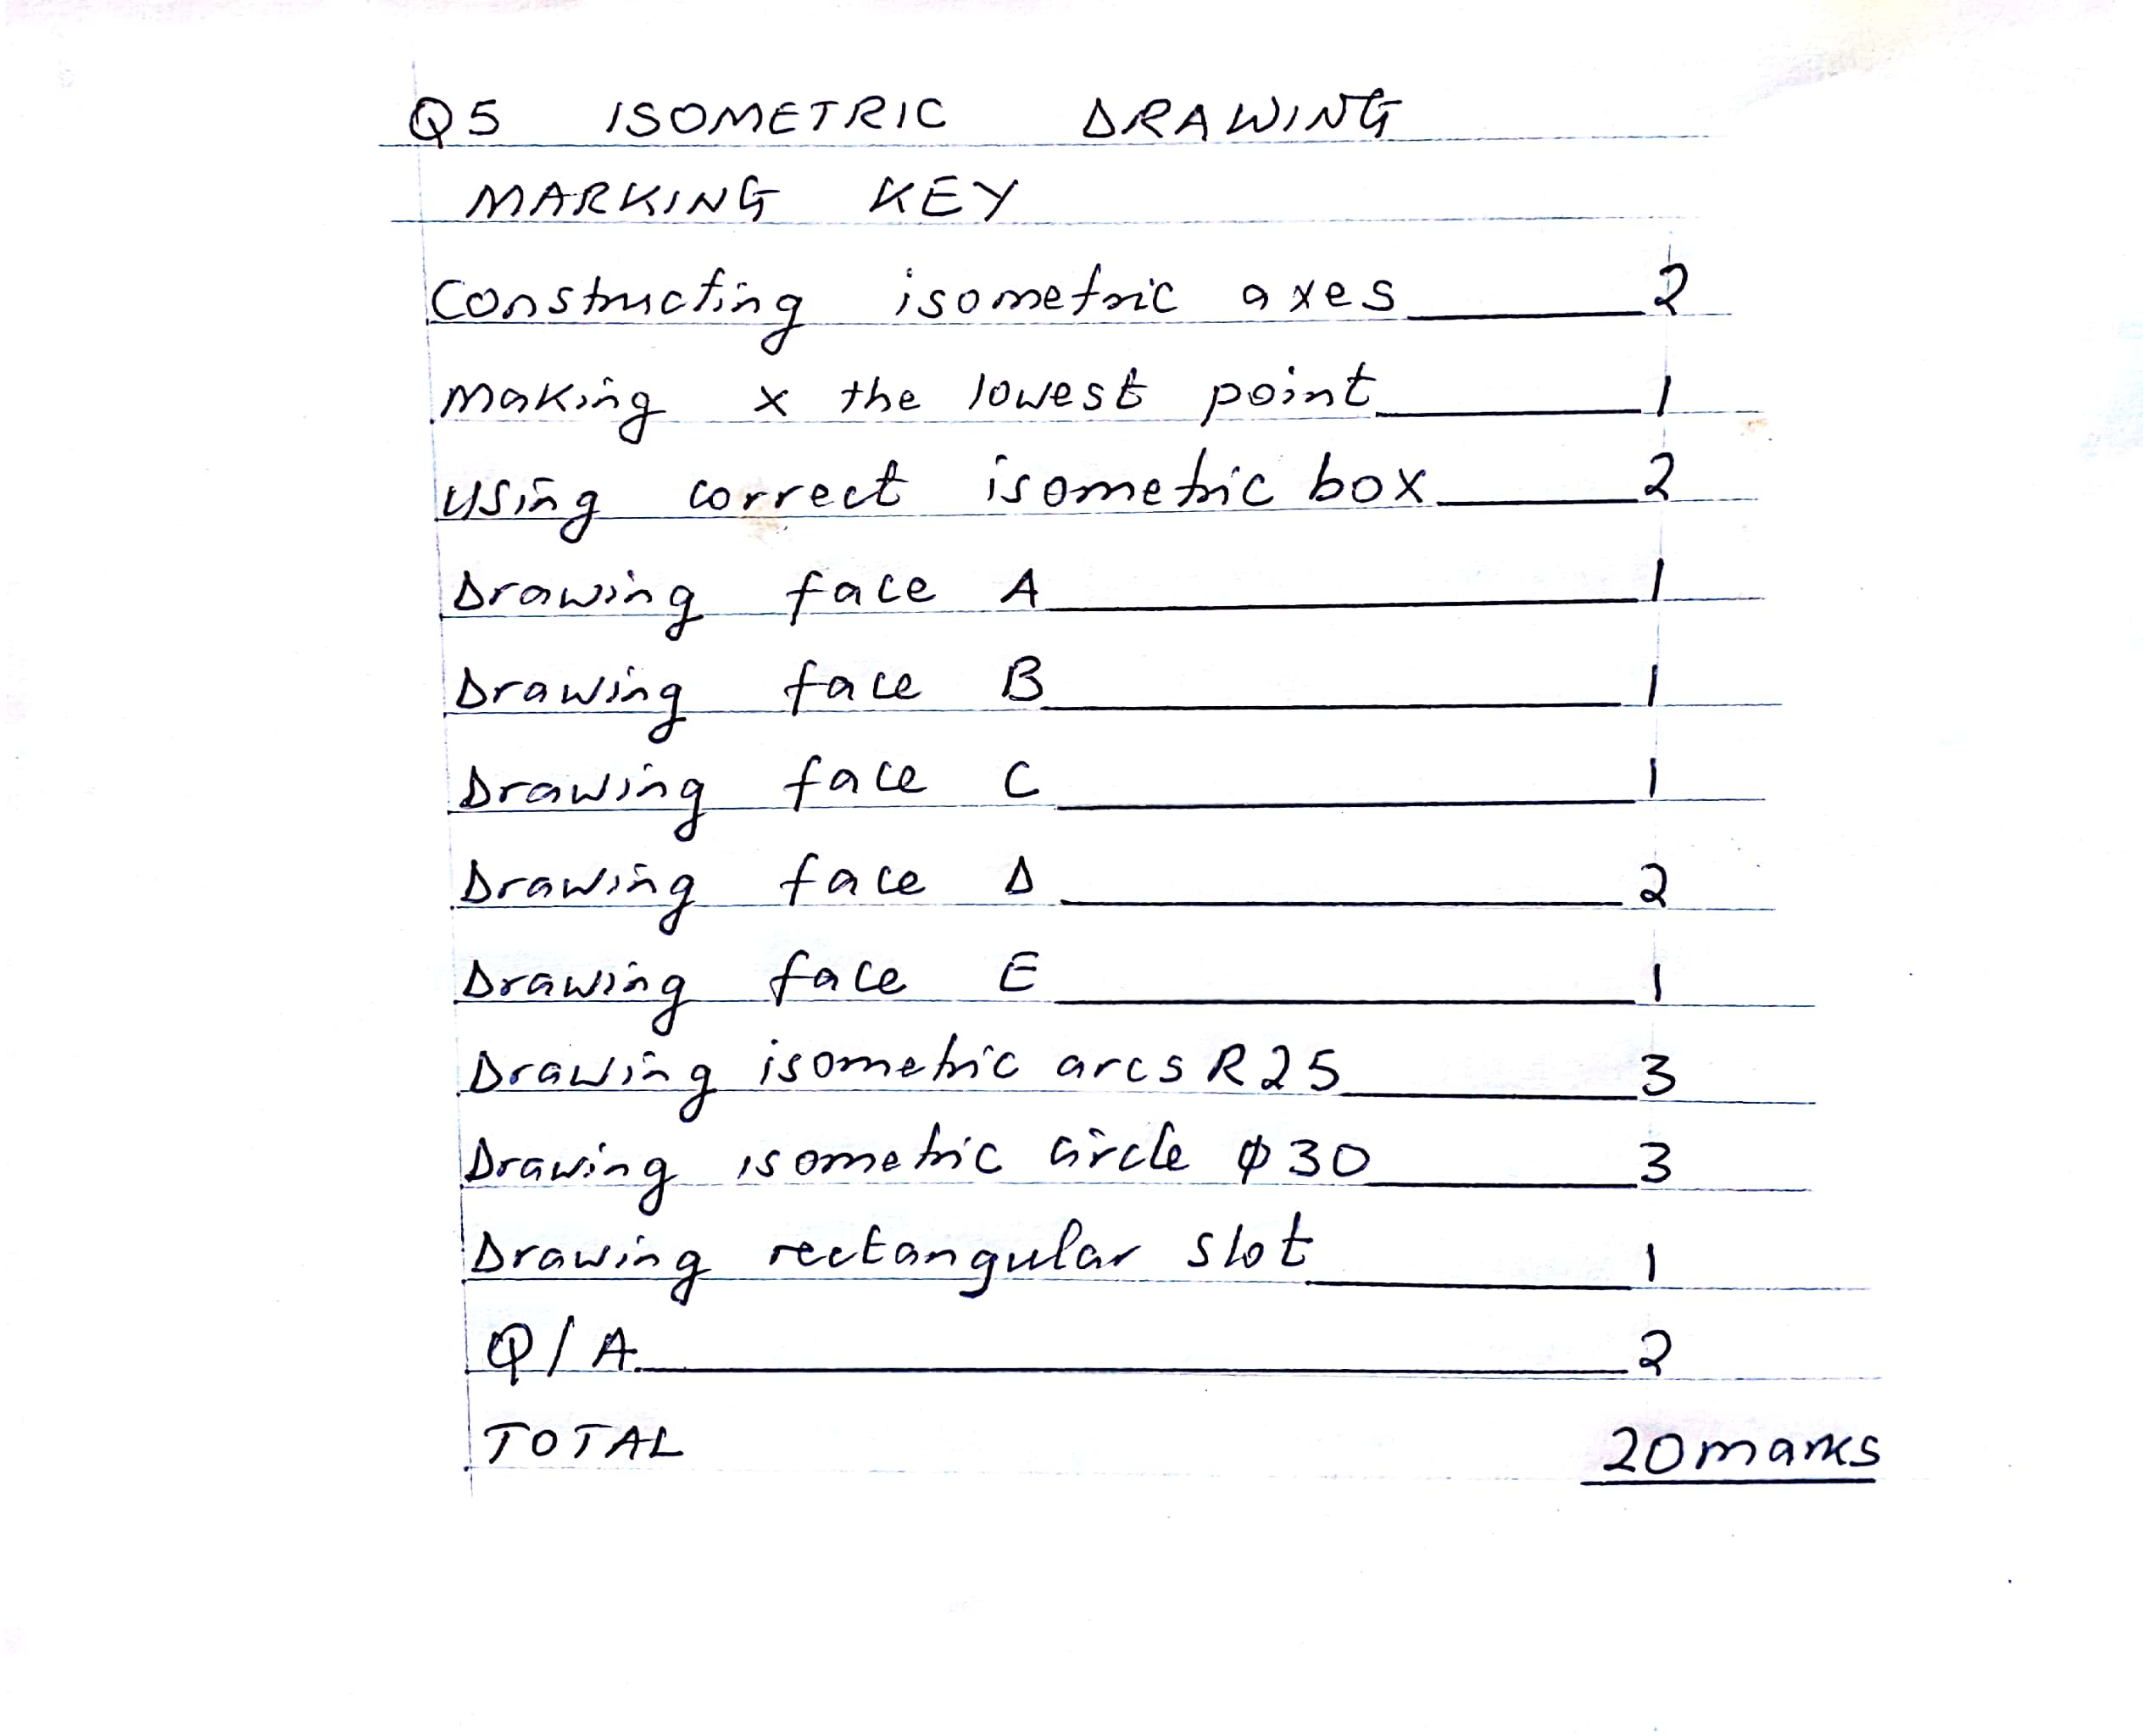

- Figure 4 shows the elevation of a right cone which has a height of 120 mm and a base diameter of 80 mm. The cone is cut by a plane as shown in figure 3.
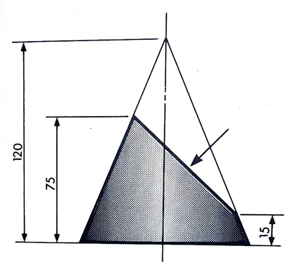
Fig 4
  - Copy the given view
  - Project the true shape of the truncated part
  - Draw the plan (20 marks)

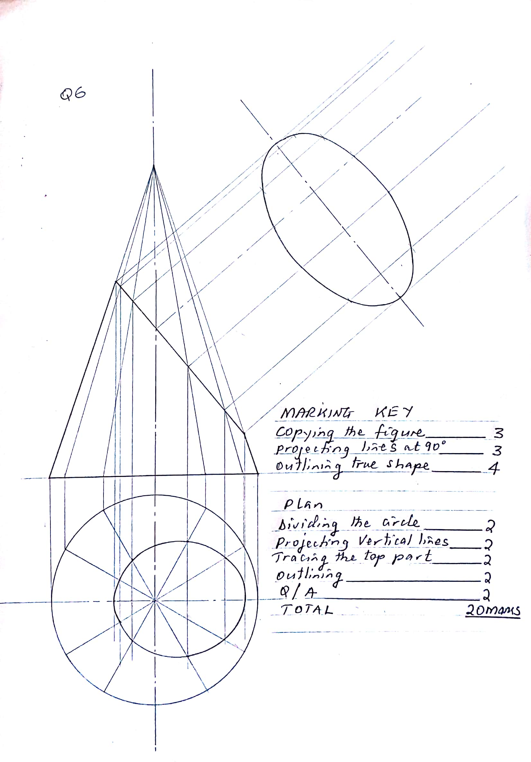
- Figure 4 below shows the plan and elevation of a triangular lamina.

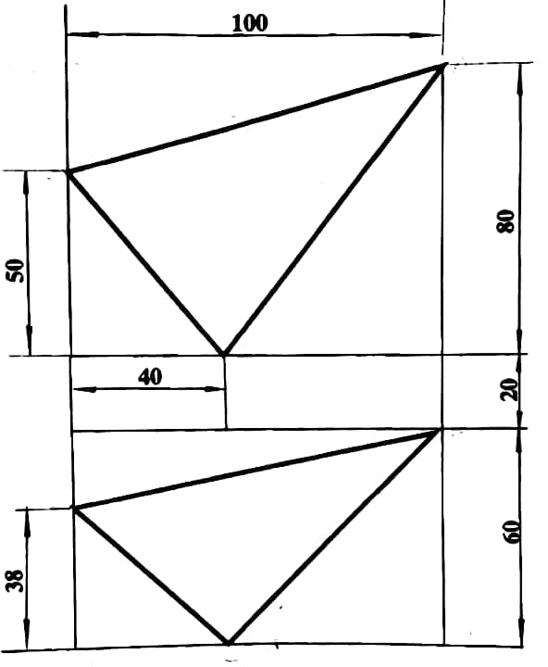
- Copy the given views (6 marks)
- Determine the true shape of the lamina (14 marks)

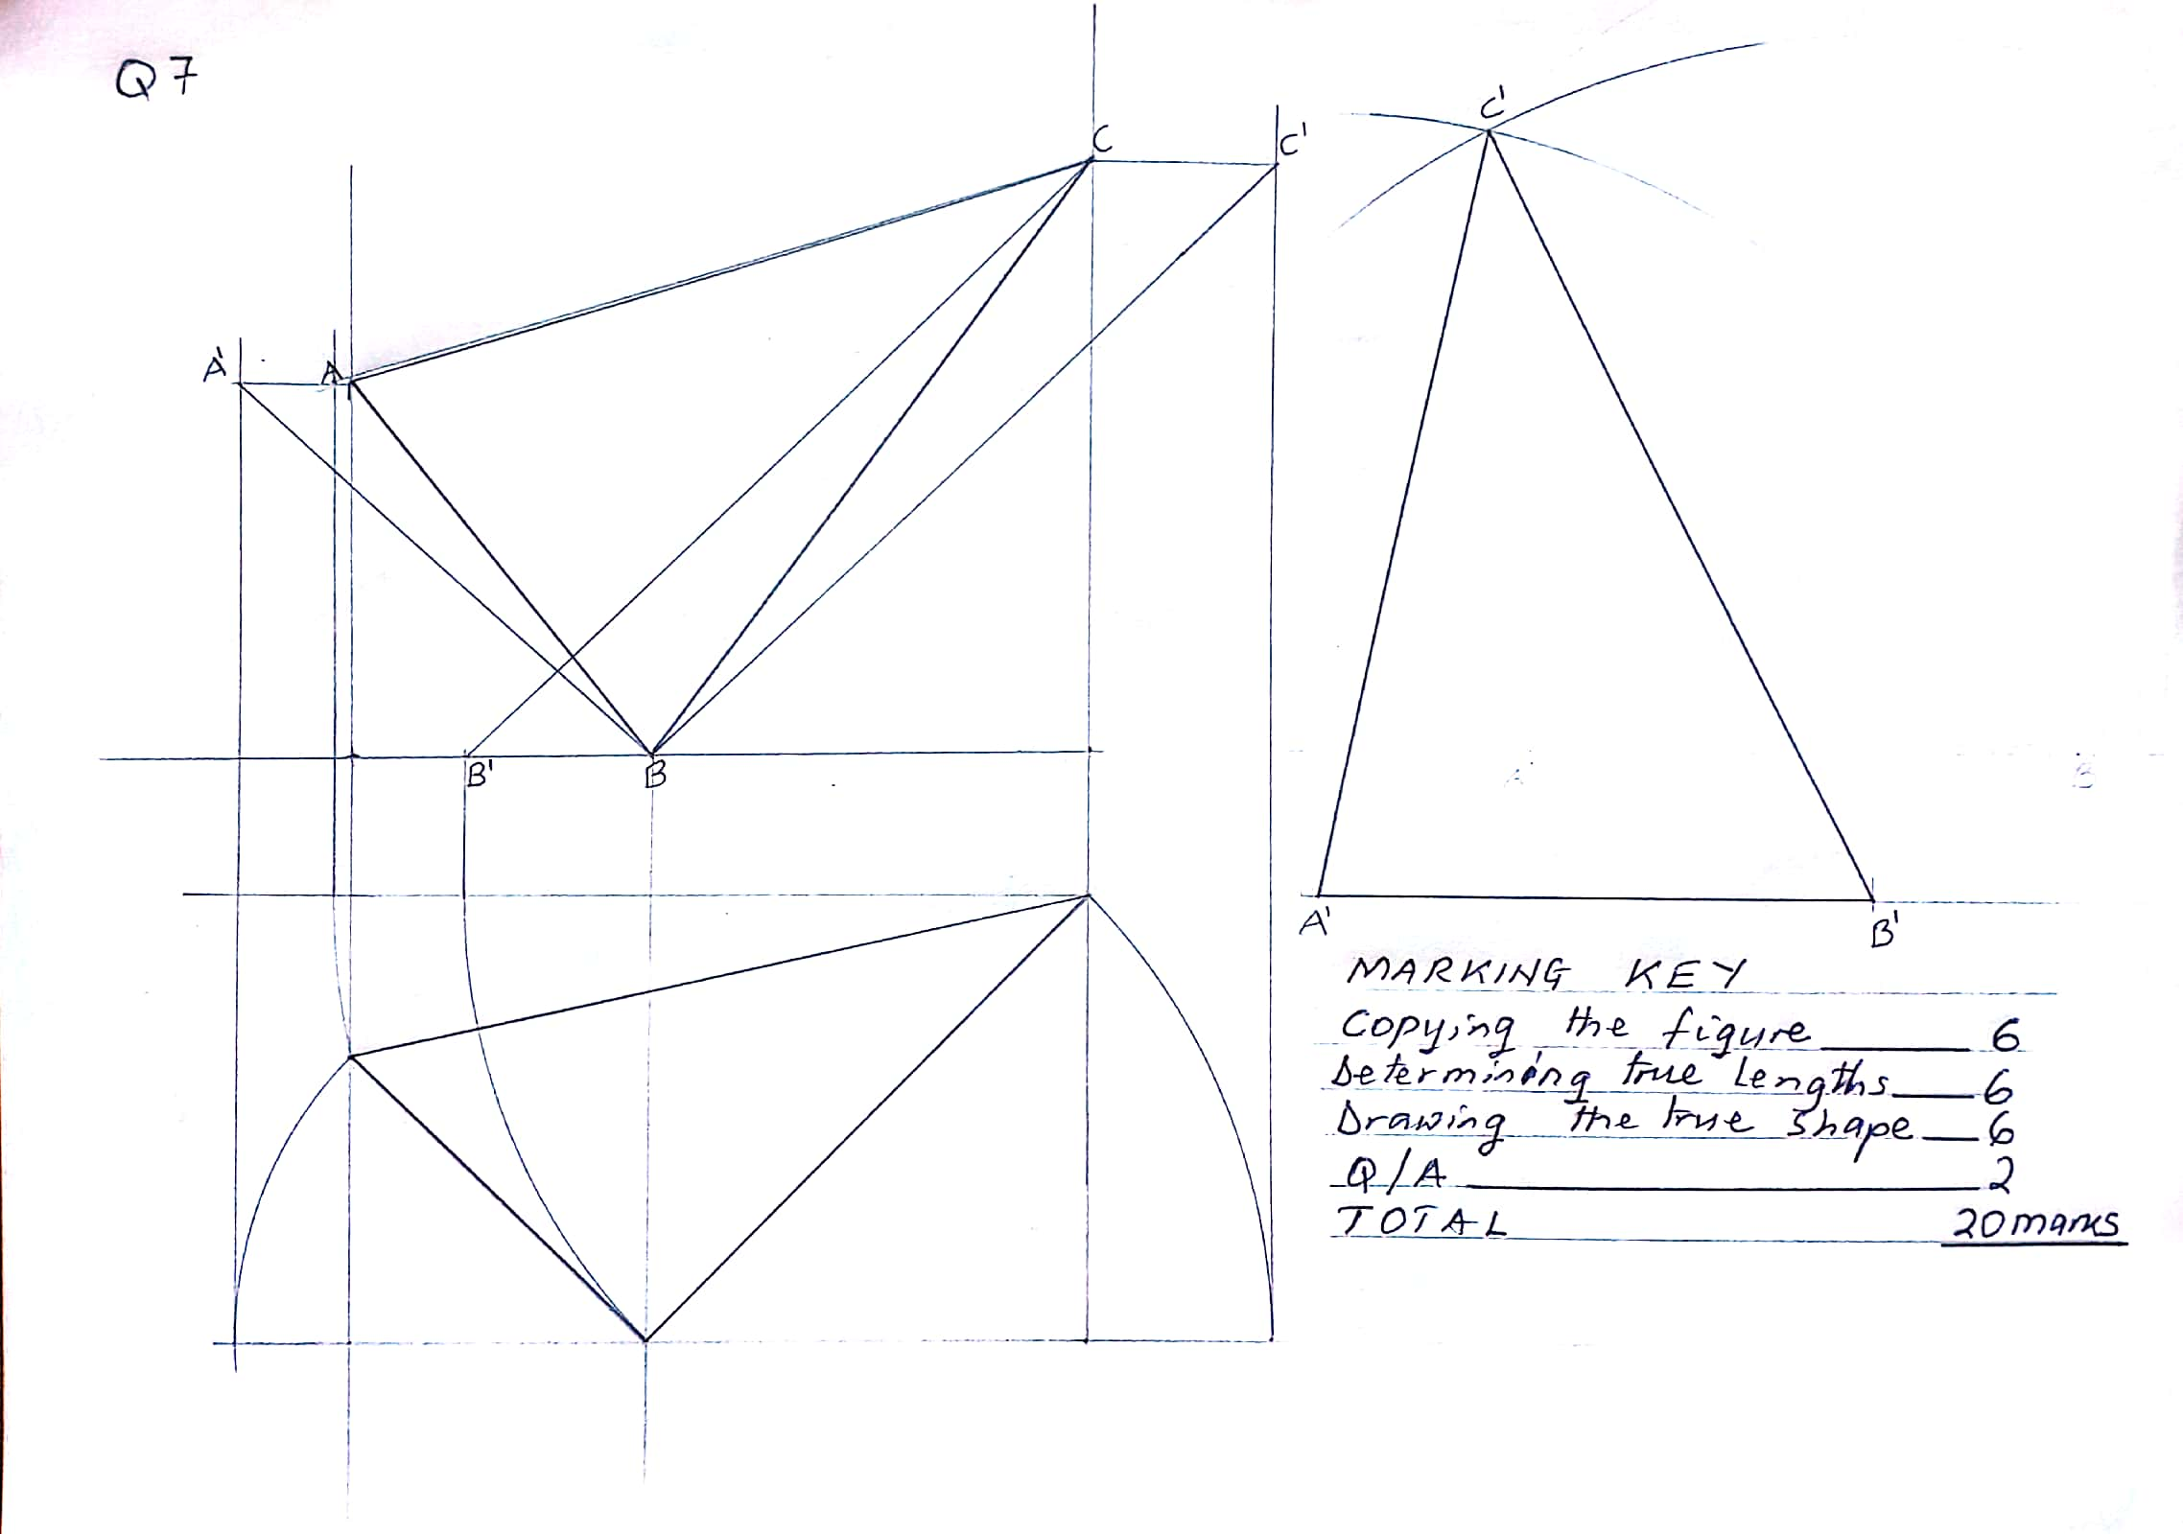
- Draw one and half convolutions (turns) of a right-hand helical spring 60 mm outside diameter. The spring is made from 10 mm square steel material with a pitch of 56 mm.
(20 marks)
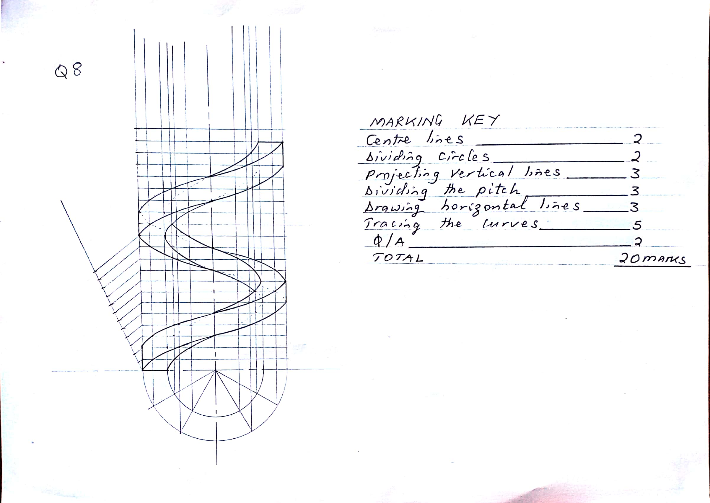

END OF MARKING KEY

